AP Calc WS#4 AROC vs IROC - Properties of Limit Name: ______

1. A rock breaks loose from the top of a tall cliff. What is its average speed (AROC) during the first 2 seconds of fall? And speed at the instant (IROC) t = 2. Hint: Free fall y = 16t2

Average rate of change AROC $\frac{Δy}{Δx}=\frac{16{(2)}^{2}-16{(0)}^{2}}{2-0}$ =

Instantaneous rate of change IROC $\frac{Δy}{Δx}=\frac{16{(2+h)}^{2}-16{(2)}^{2}}{(2+h)-2}$ =

Now you do. What is its average speed during the first 3 seconds of fall? And speed at the instant t = 3.

***We say, the AROC has the limit value IROC. The written symbols for limit $\lim_{x→c}f(x)=L$***

***How do we read it out loud? Write the limit of identity function using symbol:***

***The limit of g(x) as x approaches k is equal to M. _____________________________________***

Given g(x) = x2 and h(x) = Find and write the limit of these two functions as x approaches 2

__________________________________ ______________________________________

Now let f(x) = g(x) + h(x), f(x) = ? _____________________________

Find the limit of f(x) using limit property and NOT using limit property. Look at cheatsheet

3. Write and find the limit of the following as x approaches to the indicate number

f(x) = 3x – 7, x → 4 h(x) = -5x + 23, x → 2 k(x) = x2 – 9x + 5. x → 3

p(x) = x2 + 3x - 6, x → -1 q(x) = $\frac{x^{2}-4x-12}{x+2}$ x → 2 f(x) = $\frac{2^{x}}{sin(x)}$ x → 3



Write and find the limit of the following as x approaches c

f(x) = x2, x → c f(x) = x2 + 5, x → c f(x) = 4x2, x → c

f(x) = x3 + 4x2 – 3 , x → c f(x) = x → c

For the following, you will find and write the limit of the functions, then use graphing calculator to confirm it.

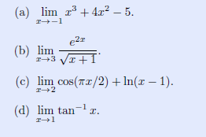

f(x) = $\frac{(x^{2}-6x+13)(x-2)}{ (x-2)}$ as x → 2 g(x) = $\frac{(x^{3}-{8x}^{2}+25x-26)}{(x-2)}$ x → 2

h(x) = $\frac{(x^{3}-{3x}^{2}-4x-30)}{(x-5)}$ x → 5 k(x) = $\frac{(x^{3}-1)}{(x-1)}$ x → 1

Given the function as shown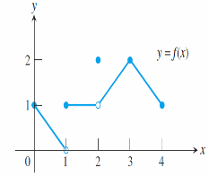, write and find the following

Right hand limit at 0 _______________________

Right hand limit at 1 _______________________

Left hand limit at 1 _______________________

Two-sided limit at 1 _______________________

Right hand limit at 2 _______________________

Left hand limit at 2 ____________________ Two-sided limit at 2 ________________

Right hand limit at 3 __________ Right hand limit at 4 _____________

Left hand limit at 3 __________ Left hand limit at 4 _____________

Limit at 3 __________ Limit at 4 _____________

Limit of piecewise-defined function: If the function is defined piecewise, then the substitution rule does not apply to limits approaching values where the definition changes, but away from those values of x it can be appropriate.



Write the piecewise function and find the limit at all given integer for the following function.

Extra point: Write out the piecewise function for f(x)

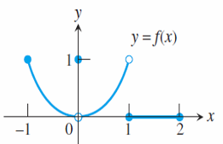 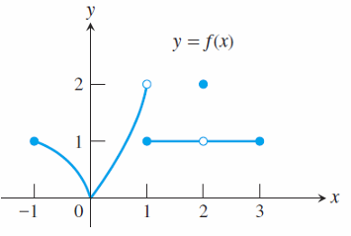

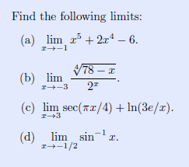

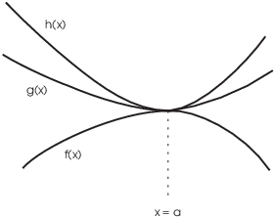The Sandwich Theorem

If g(x) ≤ f(x) ≤ h(x) for all x ≠ c in some interval about c and

$\lim_{x→c}g(x)=\lim_{x→c}h(x)=L$ then $\lim_{x→c}f(x)=L$

Use Sandwich (Squeeze) theorem to find $\lim_{x→0}\frac{sinx}{x}$

Hint g(x) = cos(x) and h(x) = 1 as the sandwich

Find $\lim_{x→0}x^{2}sin\left(\frac{1}{x}\right)$ Graph to illustrate Hint -x2 < x2 sin(1/x) < x2